ANNUAL R

EPORT

2019
Steps Alano Club
Email: sac@stepsalanoclub.org  Website: stepsalanoclub.org | 3974 Humphrey Street  Saint Louis, MO 63116
TABLE OF CONTENTS
TO OUR MEMBERS 3
Strategic Highlights and Accomplishments 3
Attendance Highlights 3
Outlook for 2024 3
Error! Bookmark not defined. 4
Statement of Financial Position 4
Statement of Comprehensive Income (Profits and Losses) 5-6
MEMBERSHIP 7
MEETING Attendance: All Meetings 7
MEETING Attendance: AA Meetings 7

TO OUR MEMBERS

Strategic Highlights and Accomplishments
Savings Account:
- Capital Fund: $1051.95 (For building improvements)
- Emergency Fund: $5,000
- Operation Savings: $204.90 (Overflow from checking account)
- Prudent Reserve: $7,500
- Wi-Fi: $665.52

Capital Improvements
- New Toilets n Meeting Room Bathroom
- New Roof on main building and workshop. $39,600 + $160 for wood replacement.
Workshop
- Tenant is a woodworker rent 500$/mo
- Tenant is planning on a longer-term stay. Good sustainable renter!

Club Maintenance
- General repairs, Hot water tank on east side of building ignitor went out. Is in the process of being repaired.

Attendance Highlights

Attendance to in person meetings has remained steady. We added a new meeting for PA. And the Monday night HA meeting has returned. Also District 2 AA is meeting here the 2nd Thursday of every month.

Outlook for 2024

General maintenance to the exterior needs to be done. (Painting the back of main building and exterior repairs to garage and workshop.)

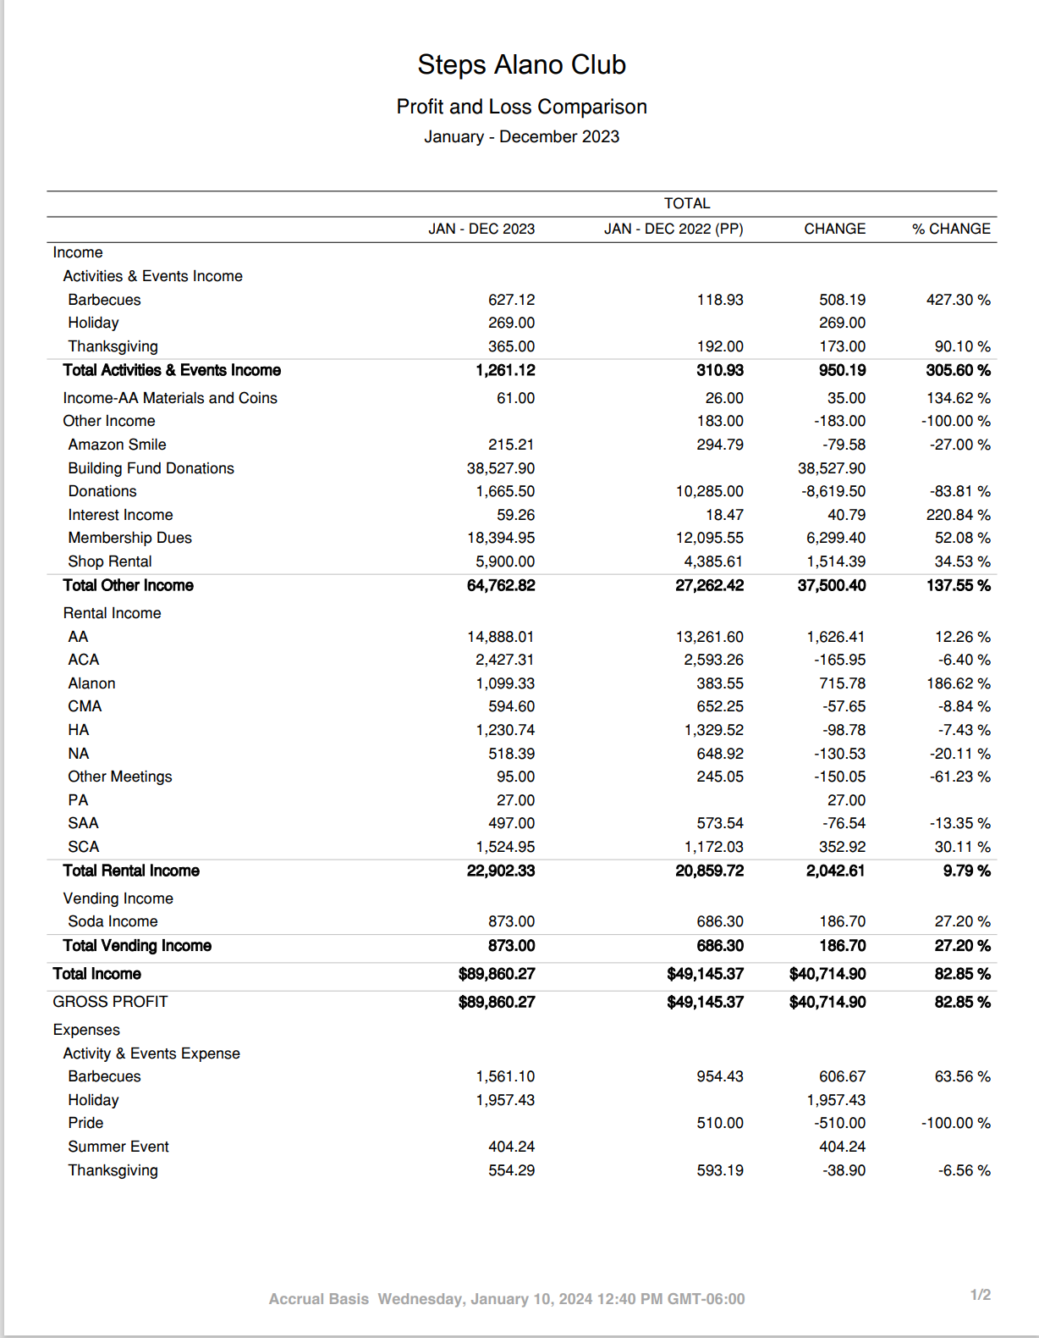
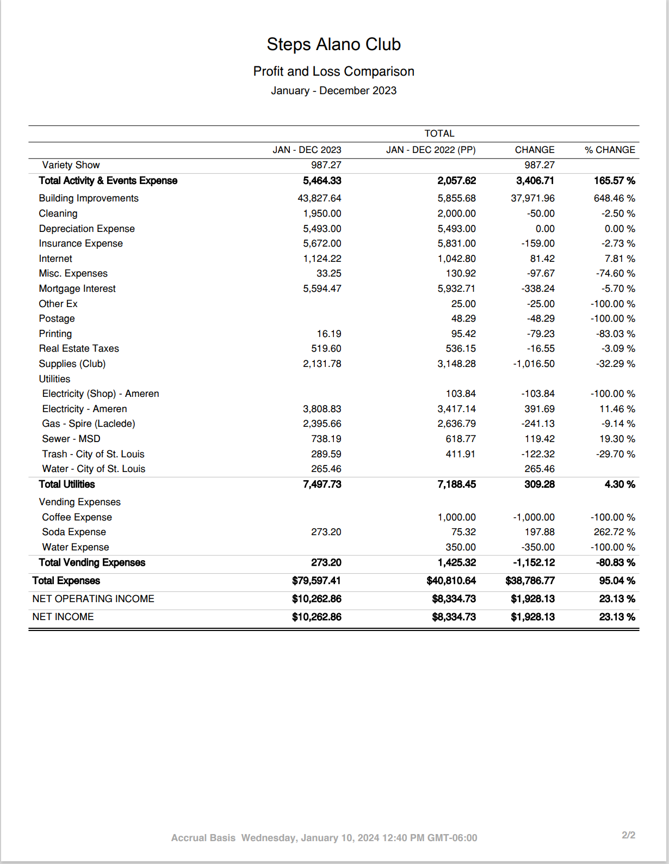
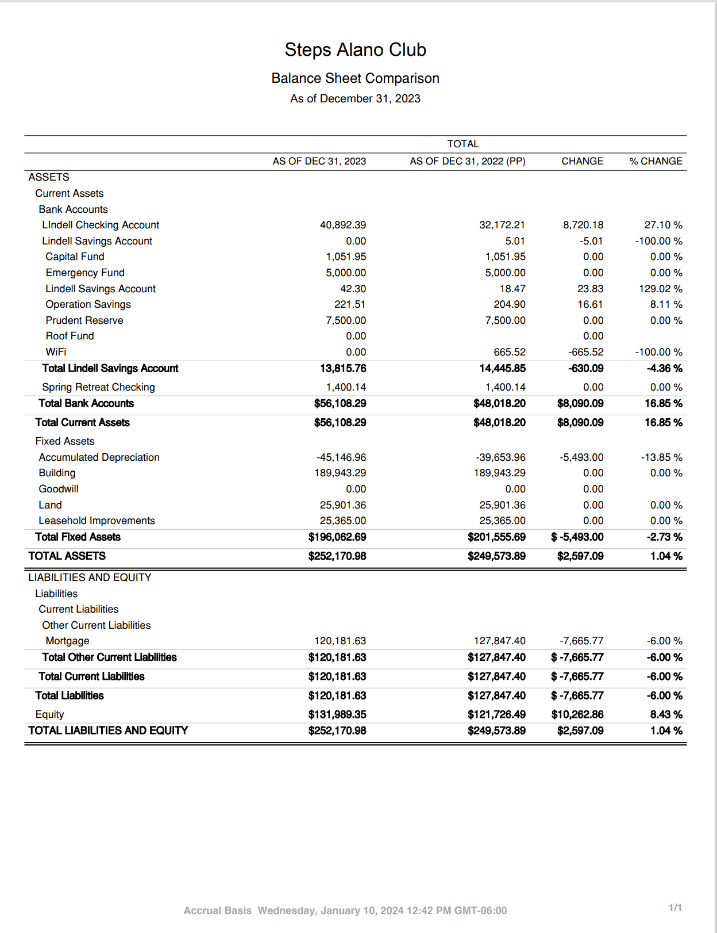

MEMBERSHIP
Memberships have increased over the last two years. We are very fortunate that many people who regularly attend meetings and could not during the pandemic have decided to become Members.

Membership Breakdown:
- 2017: 75 members
- 2018: 61 members
- 2019: 61 members
- 2020: 89 members
- 2021: 106 members
- 2022: 86 members
- 2023: 99 members

MEETING Attendance: All Meetings
Attendance is back to normal. All meetings are meeting in person. Some meetings are still providing ZOOM opportunities.

MEETING Attendance: AA Meetings
AA attendance is very strong and had returned to pre pandemic levels in many meetings

